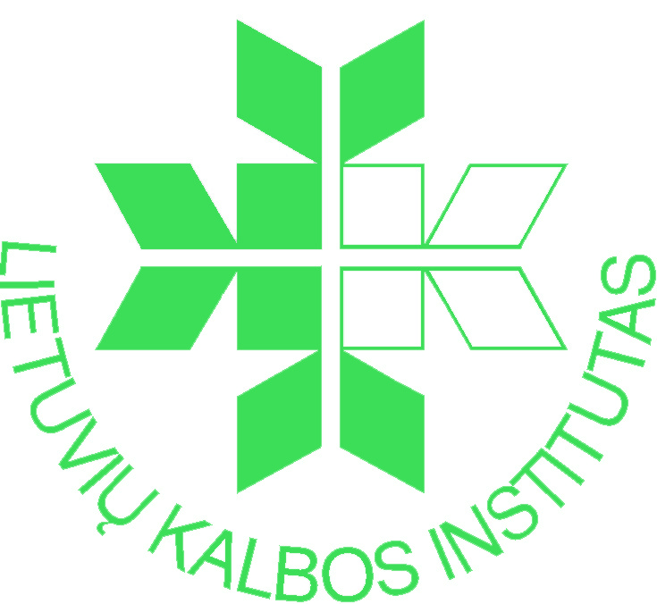 | Institute of the Lithuanian Language  Centre of Lexicography

International Scientific Conference

COMPREHENSIVE DICTIONARIES IN JUNCTION OF CENTURIES

11–12 September 2014

P. Vileišio street 5, LT-10308 Vilnius, Lithuania
Phone: +370 263 80 46, Fax: +370 5 234 7200

REGISTRATION FORM

First name:
Last name:
Degree/Title:
Position:
Institution:
Address:
Phone:
E-mail:

Title of paper
Abstract (up to 500 characters)

Other information
Requirements for presentation: Computer
Slide projector
Other

Registration form and abstract should be sent via e-mail to zodynai2014@gmail.com
by 7 March 2014.

Preliminary time for presentation: 15 min + 5 min for discussion.

