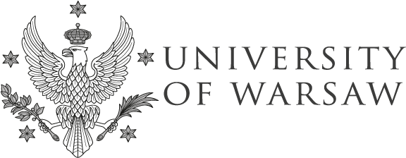
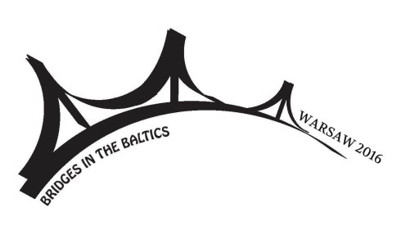

BRIDGES IN THE BALTICS

Warsaw 2016
September 30th–October 1st
Call for papers

Subdepartment of Baltic studies at the University of Warsaw and University of Tartu would like to invite you to participate in the Fourth Baltic Student Conference “Bridges in the Baltics”, which will take place in Warsaw (Poland) on September 30th–October 1st 2016.

As in previous years, the aim of the conference is to bring together students interested in Baltic studies and give them the possibility to meet, present their academic work, learn from each other and make new contacts. We invite everyone who is currently pursuing a Bachelor’s, Master’s or PhD degree at any university in the Baltic States or elsewhere.

The conference welcomes proposals concerning any of the following aspects of the society and culture of the Baltic countries:

- language and linguistics
- literature, folklore and arts
- cultural and biographical studies
- media, film and communication
- history and memory

If your topic does not fit into any of the categories listed above, please do not hesitate to submit your abstract anyway.

The working languages of the conference are Estonian, Latvian, Lithuanian, English and Polish. Everyone is welcome to give their presentation in any language mentioned above; however, your abstract and slides should be in English. Presentations will be 20 minutes long with an additional 10 minutes for questions.

Please submit the abstract of your paper (max. 250 words) to the address: bridgesinwarsaw@gmail.com by 1st of June 2016. Include the following information: name, title of your paper, university, academic level (BA, MA, PhD student), e-mail address, language of your presentation. Letter of acceptance will be sent by June 15th.

See you in Warsaw!

Conference homepage:
http://www.maailmakeeled.ut.ee/et/osakonnad/fourth-baltic-student-conference-bridges-baltics-warsaw-2016

