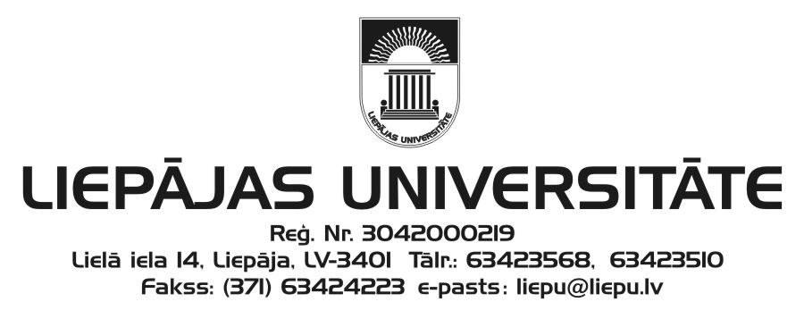
Liepāja University
Faculty of Humanities and Arts
and
Kurzeme Institute of Humanities
invite you to participate in

the 22nd International Scientific Conference
“The Word: Aspects of Research”
which will be held at Liepāja University
30 November–1 December 2017

Please submit your application (see the attached form) to the Scientific and Organising Committee (e-mail: balti@liepu.lv) by 14 October 2017.
The acceptance letter will be sent by 26 October 2017.

Working languages: Latvian, Lithuanian, English, German, and Russian.

Conference fee: EUR 65.00
Please transfer your participant fee by 7 November 2017 to the following account:
Liepāja University
Lielā iela 14, Liepāja, LV-3401
Reg. No.: LV90000036859
Account: LV45TREL9150190000000
Indicate: your first name, surname
Details: conference “The Word: Aspects of Research” participant fee
ECC – 21499

Dr. Philol. Ieva Ozola, Head of the Scientific Committee
Dr. Philol. Linda Lauze, Head of the Organising Committee

Address of the Scientific and Organising Committee:
Liepāja University
Faculty of Humanities and Arts
Kūrmājas pr. 13
Liepāja, LV-3401
Dr. Philol. Anita Helviga, Secretary
Phone: (+371) 63483781
e-mail: balti@liepu.l

22nd International Scientific Conference
“The Word: Aspects of Research”
30 November–1 December 2017
Liepāja
APPLICATION FORM

FiFirst name, surname
ScScientific
(a(academic) degree
CCurrent doctoral studies (institution, programme)
JJJob, position
E-E-mail
PPhone
PPostal address
TTheme of the speech (title)
AAbstract

Presentation equipment required

_______
(date)

