6th Baltic Student Conference “Bridges in the Baltics”
5–6 October 2018
University of Tartu, Estonia

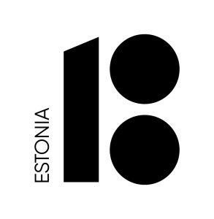 | 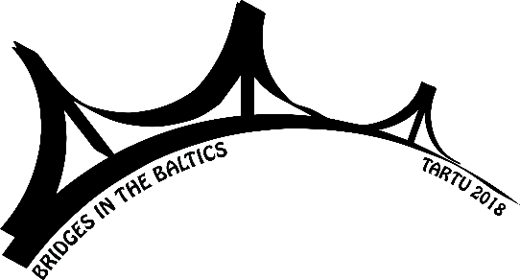 | 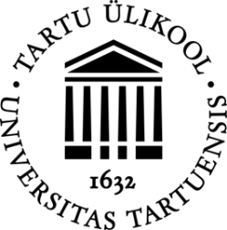

Call for Papers

University of Tartu College of Foreign Languages and Cultures invites you to the 6th Baltic Student Conference “Bridges in the Baltics” to be held on 5–6 October in Tartu. The conference is dedicated to the 100th anniversary of the Baltic States.

The aim of the conference is to bring together students whose studies and research focus on the languages or culture of the three Baltic States, to give them the possibility to meet their peers from other countries and universities, to present their academic work and interests, learn from each other and make new contacts. The conference welcomes everyone who is currently pursuing a Bachelor’s, Master’s or PhD degree at any university in the Baltic States or elsewhere.

The conference welcomes proposals concerning any of the following aspects of the Baltic countries:

- language and literature
- history, folklore and culture
- arts, film and music
- cultural, biographical and gender studies
- modern technology and innovation in the Baltic societies
- political and social developments in the Baltic region

The working languages of the conference are Estonian, Latvian, Lithuanian and English. Everyone is welcome to give their presentation in any language mentioned above and we encourage using the languages of the Baltic States. However, the abstract and presentation slides should be in English.
Please send your abstract (not exceeding 200 words) and a short CV including personal details, education and academic interests (not exceeding one page) until May 14th to bridgesintartu@gmail.com. Letters of acceptance will be sent by June 1st.

Facebook: https://www.facebook.com/balticbridge/
Instagram: www.instagram.com/baltistikatartu/
#bridgesinthebaltics

