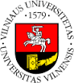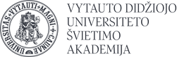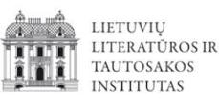

REGISTRATION FORM FOR
SHORT-TERM VISITS FROM FOREIGN CENTRES OF THE BALTIC (LITHUANIAN) STUDIES TO LITHUANIAN SCHOLARLY AND ACADEMIC INSTITUTIONS

The name of the centre of the Baltic (Lithuanian) studies:

The name and surname of a lecturer coming for a visit:

Preliminary dates of a visit:

Purpose of a visit:

The institution for a visit:
- Institute of Lithuanian Literature and Folklore
- Vilnius university
- Vytautas Magnus University

Head of the centre:
Name and surname Signature

Short-term visits are organized under the project of the EU structural funds “Lithuanian Academic Scheme for International Cooperation in Baltic Studies” (No. 09.3.1-ESFA- V-709- 01-0002).
